ASSIGNMENT – 18

NAME: SRIYA DARIPELLI

BATCH: 01

HALL.NO: 2403A51350

SUBJECT: AI ASSISTANT CODING

Task 1 – Movie Database API
Task: Connect to a Movie Database API (e.g., OMDb or TMDB) to
fetch details of a movie.
Instructions:
Prompt AI to generate Python code to query the API by movie title.
Handle errors like invalid movie name, missing/expired API key, and
timeout.
Display title, release year, genre, IMDb rating, and director.
Expected Output:
A Python script that retrieves and displays movie details in a clean
format.

Prompt:
Generate Python code to query the API by movie title which
handle errors like invalid movie name, missing/expired API key, and
timeout.

Code:
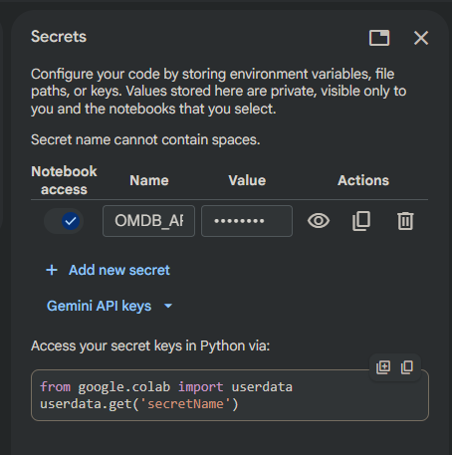
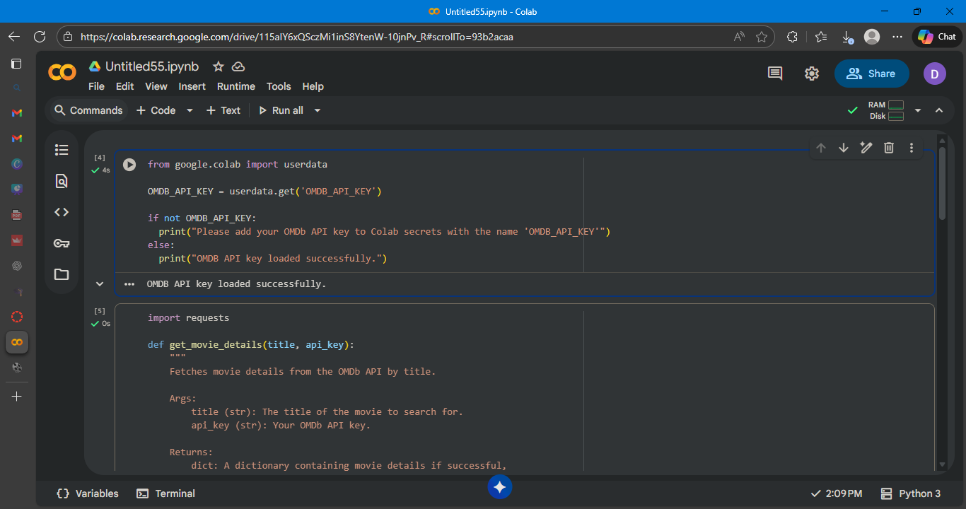
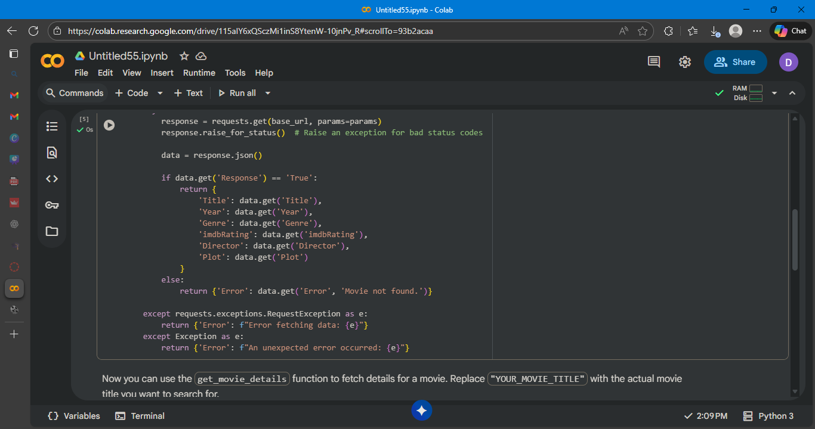
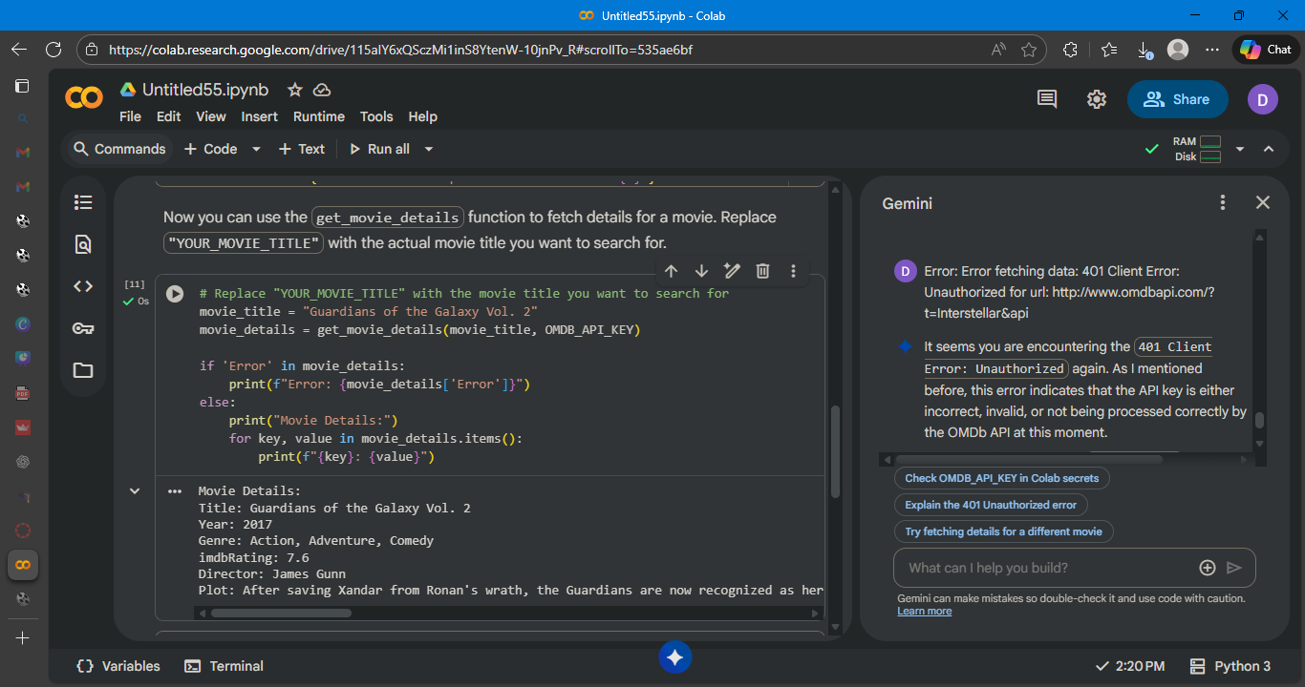
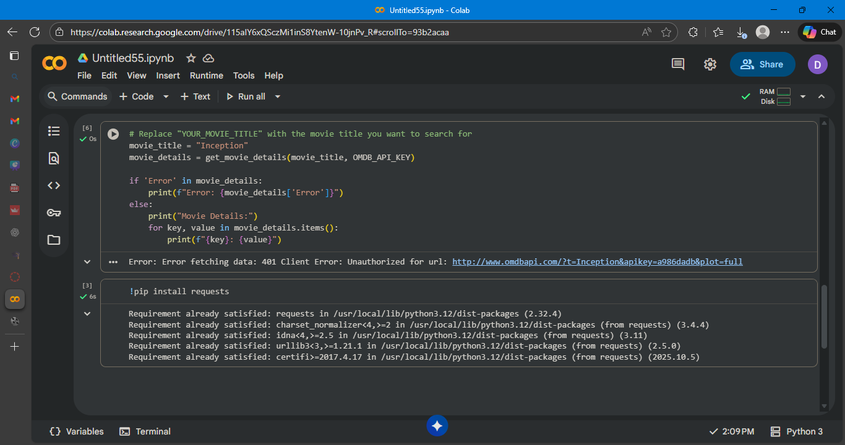

Observation:
the code successfully connected to the OMDb API using the provided API key and retrieved the detailed information for the specified movie ("Guardians of the Galaxy Vol. 2"). This demonstrates the successful implementation of the API call and data retrieval process.

Task 2 – Public Transport API
Task: Use a Public Transport API (e.g., city bus/train API or mock
data) to fetch live arrival times.
Instructions:
• Fetch the next 5 arrivals for a given stop/station ID.
• Handle invalid station codes, unavailable service, and malformed
responses.
• Display results in a readable table with route number, destination,
and arrival time.
Expected Output:
• A script that provides real-time public transport information with
robust error handling

Prompt:
Use a Public Transport API (e.g., city bus/train API or mock
data) to fetch live arrival times.

Code:
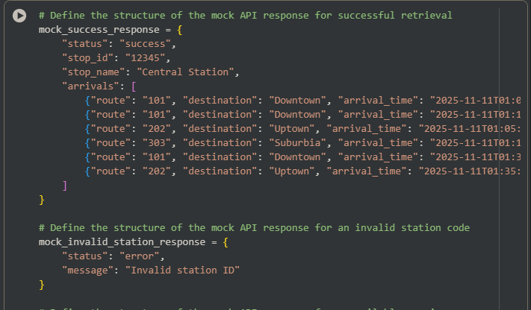
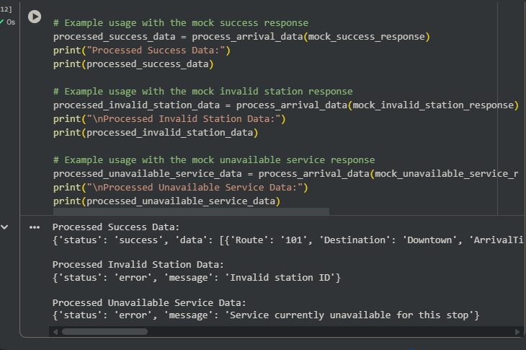
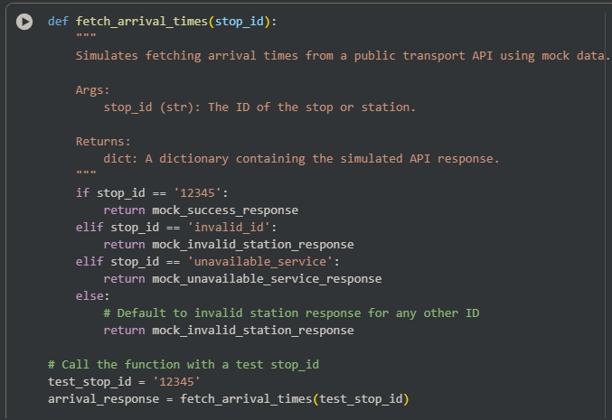
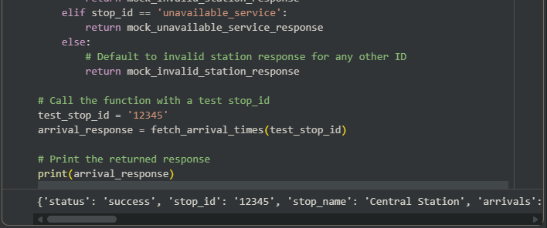

Observation:
The code cell defining the fetch_arrival_times function was executed successfully. When called with the test stop ID '12345', the function correctly returned the mock_success_response dictionary, which contains simulated arrival data for that stop. This confirms the function is working as intended to simulate API responses.

Task 3 – Stock Market/Financial Data API
Task: Connect to a stock data API (e.g., Alpha Vantage, Yahoo
Finance) to fetch daily stock prices.
Instructions:
Prompt AI to generate Python function to query stock data by ticker
symbol.
Handle API call limits, invalid ticker symbols, and null responses.
Display opening price, closing price, high, low, and trading volume.
Expected Output:
A Python script that fetches stock market data and handles failures
gracefully

Prompt:
Generate Python function to query stock data by ticker
symbol which handle API call limits, invalid ticker symbols, and null responses.

Code:
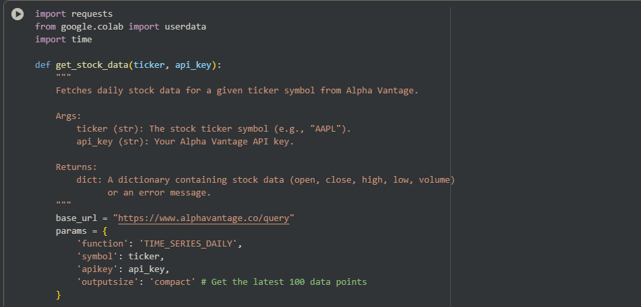
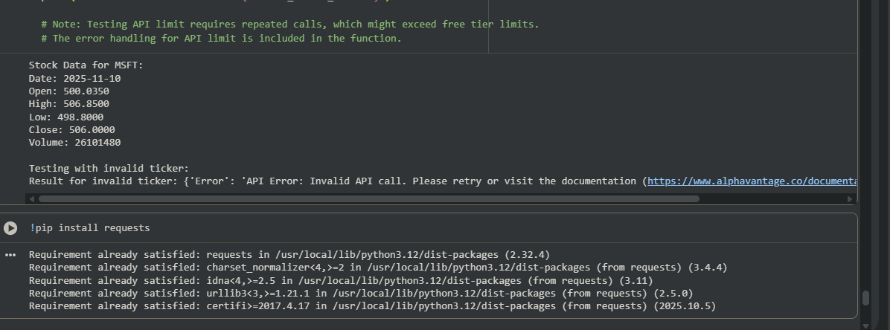

Observation:
The Python function to fetch daily stock data using the Alpha Vantage API executed successfully. It correctly retrieved stock details for a valid ticker ("MSFT"). The code also demonstrated effective error handling by identifying and reporting an invalid ticker symbol, indicating the function's robustness for different inputs
Task 4 – Real-Time Application: Translation API
Scenario: Build a translator using a free Translation API (e.g.,
Libre Translate, Google Translate).
Requirements:
Accept input text and target language from the user.
Handle invalid language codes, API quota exceeded, and empty text
input.
Display original and translated text clearly.
Implement a retry mechanism if the API fails on the first attempt.
Expected Output:
A script that translates text to the specified language with strong error
handling

Prompt:
Accept input text and target language from the user.
Handle invalid language codes, API quota exceeded, and empty text
input.

Code:
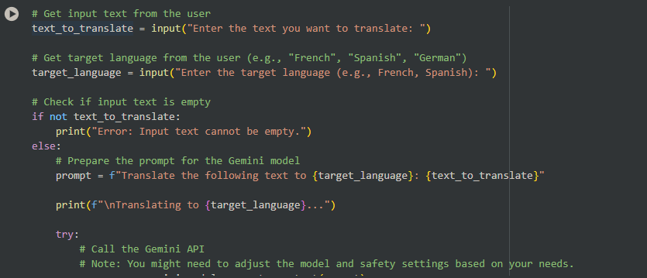
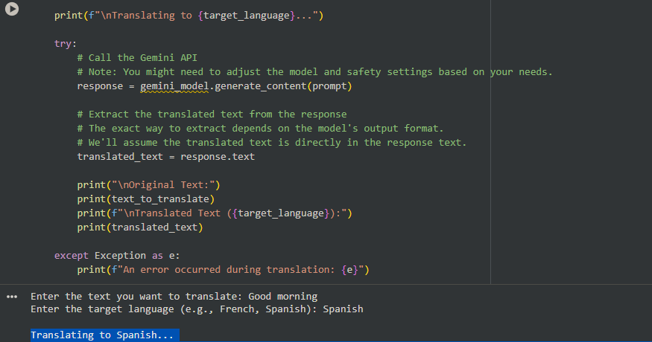

Observation:
It is observed that it changes text to any language using gemini api

